**CAR ANALYZER**

D.Sathya1, Sriram R2, Ashwin Balaji G.2, Irshaad A.2

1Assistant Professor, 2UG Scholar, 1,2 Dept of CSE

Kumaraguru College of Technology, Coimbatore, Tamil Nadu.

sathya.d.cse@kct.ac.in

***Abstract***

***As kids, we can all relate to having fond memories of going from dealership to dealership with our parents, jumping in and out of the backseats of different cars, testing out all the different features. While test drives haven’t fallen by the wayside, the modern 2017 car shopper will only visit an average of 2 dealerships on their journey to buying their perfect new car.***

***The car buying journey has radically changed due to the digital boom over the past couple years. People are spending less time in dealership showrooms and more time researching and building out the perfect car. With the massive amount of information available on every model, it’s important to attract potential dealers to provide the right content, at the right time.***

**I. INTRODUCTION**

In India, over the last couple of years, the domestic passenger car market has witnessed a phenomenal growth. High degree of competition compels players in this industry to understand specific market needs while still providing value, in order to ensure success. In a particular year, a large portion of customers buy their second car. So, for marketers, it is important to understand the variables that influence consumers decision to purchase a second car. In this backdrop, an attempt has been made to uncover influencing factors behind purchase decision of a second car. From the research, it has been found that the segment who is buying second car has different priority factors that guide its buying decision. The study reveals that there are seven major factors that influence buying behaviour of a second time car buyer.

Several approaches based on machine learning are implemented, such as Naive Bayes, SVM Classifier, Linear Regression.

That’s perpetually counting on previous knowledge. Miss classification (Doesn’t supports Multi-Label Classification), Less prediction, Normally, lots of users tend to buy vehicles based mostly upon false data given by on-line automotive websites, People sometimes take into account the value instead of the necessities that they have while not knowing that there are higher cars which can suit them beneath their budget.

The KNN formula trained with the options extracted and predict the simplest automobile model. Well, KNN it capable of doing each classification on multi-labelled knowledge. The profit is that you just will capture way more complicated relationships between your knowledge while not having to perform troublesome transformations on your own. KNN formula from the Scikit-learn Python library that implements this algorithm. This formula produces a prediction label. Label encoder technique is employed label the automobile model within the dataset and makes classification additional correct than general label data. when the inverse label data, it offers foreseen automobile model all details. Also this implementation is more improved with user interface interface for simple accessing by the users.

**II. RELATED WORK**

Factors Influencing the Purchase Decision of Passenger Cars in Puducherry:

The automobile industry is one of the fastest growing sectors of the world. India is the fourth largest exporter of passenger car and 6th largest producer in the world. A number of leading global automotive companies entered with the joint ventures and started producing variety of models with different features and providing value added services to attract the Customers. Hence the customer’s decision making becomes Complicated. Therefore, this study makes an attempt to identify the factors influencing the customers to purchase a passenger car. The secondary data was collected from 100 passenger car users of Puducherry with the help of a structured questionnaire. Various hypotheses were framed and tested. It is found that the customers were more focused on performance, technical features of the car during their purchase. Environmental factors were given least importance during their purchases. The major weakness of Indian policy framework is interstate differences and there are no much publications to create awareness among the general public. Therefore, it is essential to create awareness among the passenger car users regarding various environmental issues.

Indian Foreign Trade with Reference to Automobile Industry

India is expected to become the third largest automobile market in the world. In a developing nation and agro based economy like India, this is a great indicator of economic development. The rapid improvement in infrastructure, huge domestic market, increasing purchasing power, established financial market and stable corporate governance framework have made the country a favorable destination for investment by global majors in the auto industry. Access to latest and most efficient technology and techniques will bring competitive advantage to the Indian players. The role of Industry will primarily be in designing and manufacturing products of world-class quality establishing cost competitiveness and improving productivity in labor and in capital. With a combined effort of manufacturers and conducive Governmental policies, the Indian Automotive industry will emerge as the destination of choice in the world for design and manufacturing of automobiles.

Study on Consumer Behaviour During Buying Purchase of a Second-hand Car:

It has been seen that majority of the respondents bought existing car from mini or compact hatchback segment. For example, 29% of respondents own mini cars, 42% respondents own compact hatchback and only 18% of them own three box sedans. Ownership age of existing car varies between one to five years. Majority of the respondents (near about 64%) would like to buy a second car after four/ five years of existing car ownership. Another interesting finding is that near about 53% of them are satisfied with their existing car and 29% of them are highly satisfied with their existing car. Respondents are asked to indicate their choice about second car segment. Out of them 40% would like to buy their new car from sedan segment and 25% would like to elevate to SUV/MPV segment. Near about 30% still would like to buy it from compact segment and a fraction would like to be a proud owner of a luxury car.The findings of this study uncover underlying factors that influence buying behaviour of a second car. However, the study is conducted in India, and the results and discussion should be viewed in context to India. However, the result may further be verified in cross country context to understand the similarities and differences among factors. Moreover, the association among notable demographic variable and the degree of influence of factors may be analysed in next phase of study. This requires further in-depth analysis with large sample size. Future research on factors influencing buying behaviour of second car should be further examined by considering additional variables and dimensions of demographic, economic, cultural, social, psychographic, and behavioural aspects.

A study on the customer preferences of automobiles using fuzzy logic:

It was decided to analyze the customer preferences in automobile for 1200cc vehicles. Survey was conducted among the consumers. Multi Criteria Decision Making Tool Graph Theory and Matrix Approach has been successfully applied to identify the consumer preferences. Fuzzy logic decision making tool was also applied to analyze the influencing factor in customer preference among the 1200cc vehicles. The scope of the study was confined to only 1200cc four wheelers. The study might be extended for 1500cc and 2000cc vehicles too.

**III. PROPOSED SYSTEM**

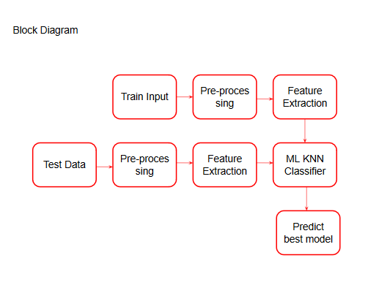

**FINAL OUTPUT WITH GUI ( Graphical User Interface )** 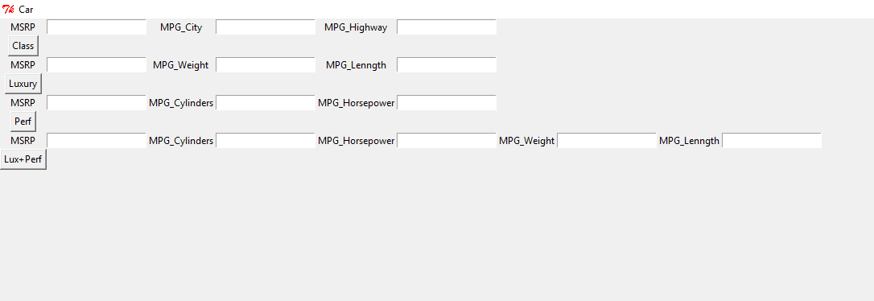

**PERFORMANCE BASED CARS SUGGESTION**

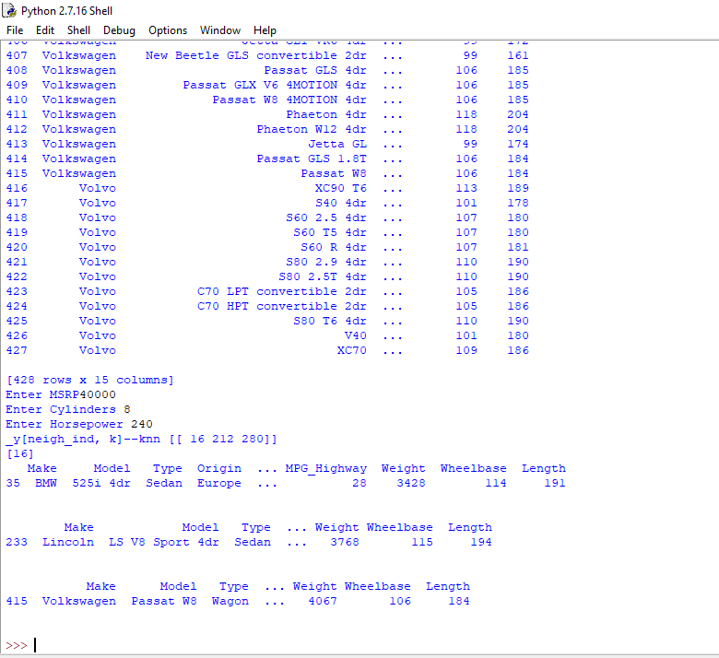

**IV. CONCLUSION AND FUTURE ENHANCEMENT**

Finally, the analysis will yield a result which will be a right choice for the user based upon the simple information given rather than more complex technical terms. Developing this application either as a website or an android app and connecting this programming logic as an backend. All of the cars will be fetched and the output will be generated with a greater presentation since it may be an website. If we plan to use this as an website then we may need javascript to animate the data in-order to appeal the user and the backend will be used in such a way that it can connect with the .csv file. Django may be an appropriate framework since it involves python as its programming preference.

**V. REFERENCES**

**[1]** Pudaruth,S. 2014. “Predicting the Price of Used Cars Using Machine Learning Techniques”, International Journal of information & Computation Technology,4(7), p.753-764.

**[2]** Kuiper, S. 2008. “Introduction to Multiple Regression: How Much Is Your Car Worth?”, Journal of Statistics Education, 16(3).

**[3]** Limsombunchai, V. 2004. House price prediction: Hedonic price model vs. artificial neural network. In New Zealand Agricultural and Resource Economics Society Conference, New Zealand, pp. 25-26.

**[4]** Bourassa, S.C., Cantoni, E. and Hoesli, M. 2007. “Spatial dependence, housing submarkets, and house price prediction”, The Journal of Real Estate Finance and Economics, 35(2), p.143-160.

**[5]** Nau, R. 2014. Notes on linear regression analysis, Lecture handouts, Duke University, Furqa School of Business, 26 nov 2014.